**Create A Basic Web Page**

1. Create a new blank HTML5 document. If you are using VS Code, click the **New File** button in the Explorer pane next to the name of the assignment.
2. Save the file as **template.html**. The file will be saved in the default user directory for GitHub. For example, on a Windows computer it should be saved to c:/users/JaneDoe/github-classroom/rsc-cis133DA-in-v12/projectRepo. **NOTE** The file will be saved into the folder for the specific project repo you are working on. Do not save the file to a different folder. If you do that, the file will not sync to your GitHub account when you Sync and Commit your work.
3. Using the appropriate tags, create **the four basic HTML elements**.
4. Insert **a multi-line HTML comment** within the head element of the web page with the following information: Course, Section, and Lesson Number and fill in the information for your course and lesson. For example:

Course: CIS133DA  
Section: 99999  
Lesson: 3

1. Give the **page a title** of: {Your MEID} - Template. Replace the {Your MEID} with your actual MEID, like the following example:

ABC1234567 - Template

1. **Save** your web page. **Sync** your file to GitHub and apply a **Commit** that says: Created template with basic HTML elements. If you need a refresher on how to Sync and Apply a commit, refer to [How to Apply a Commit and Sync your Files to GitHub](https://riosalado.coursearc.com/content/cis-public/git-github-and-vs-code/working-on-activities-and-assignments)
2. Using the appropriate tags, add the following content to your web page:
   * Create a **first-level heading** with the following text: Basic Template
   * Create a **paragraph** under this heading with dummy text (see [Working with Paragraphs](https://riosalado.coursearc.com/content/cis133da-in-v12/lesson-3-introduction-html/working-with-paragraphs)) as the text within the paragraph.
   * Create a **second-level heading** with your first and last name as the text.
   * **Add at least one paragraph** under this second-level heading with a brief intro about yourself so your instructor can get to know you a bit more. You can include details about your educational goals, what you hope to get out of the course, etc.
   * Create **another paragraph** after your bio paragraph(s) with general contact information with each contact method **on a separate line** within a single paragraph. Include:
     + The text "Phone:" along with a fake phone number.
     + The text "Email:" along with your student email address.
3. Create **another paragraph** for the page copyright info. For the text use the following format:

Copyright {YEAR} by {Your Full Name}

1. **Save** your web page. **Sync** your file to GitHub and apply a **Commit** that says: Added Content.

**Example Project**

This is an example of what the project should look like before you submit your project.

[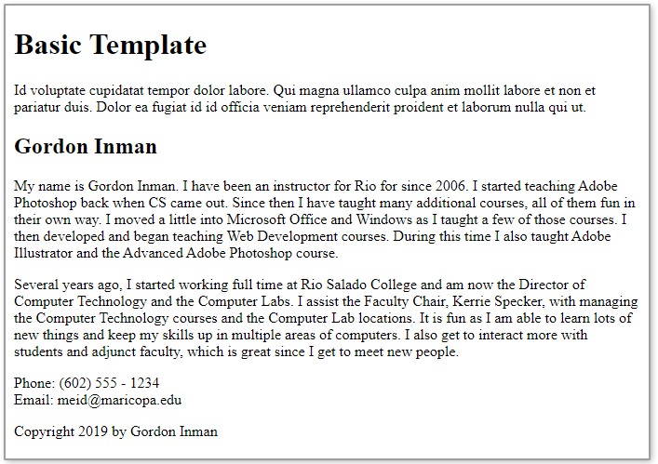](https://raw.githubusercontent.com/rsc-cis133DA-in-v12/CourseResources/main/L3-example1.png)